

While testing the application or executing the test cases, the test engineer may not get the expected result as per the requirement. And the bug had various names in different companies such as **error, issues, problem, fault, and mistake**, etc.

|  |  |  |
| --- | --- | --- |
| **Terms** | **Description** | **Raised by** |
| **Defect** | When the application is not working as per the requirement. | Test Engineer |
| **Bug** | Informal name of defect | Test Engineer |
| **Error** | Problem in code leads to the errors. | Developer, Automation Test Engineer |
| **Issue** | When the application is not meeting the business requirement. | Customer |
| **Mistake** | Problem in the document is known as a mistake. | -- |
| **Failure** | Lots of defect leads to failure of the software. | -- |

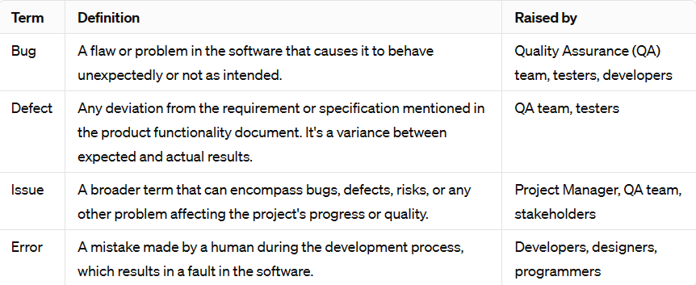

|  |  |  |
| --- | --- | --- |
| SNO | Reason |  |
| 1 | Wrong coding | Wrong coding means improper implementation. |
| 2 | Missing coding | missing coding means that the developer may not have developed the code only for that particular feature. |
| 3 | Extra coding | extra coding means that the developers develop the extra features, which are not required according to the client's requirements. |

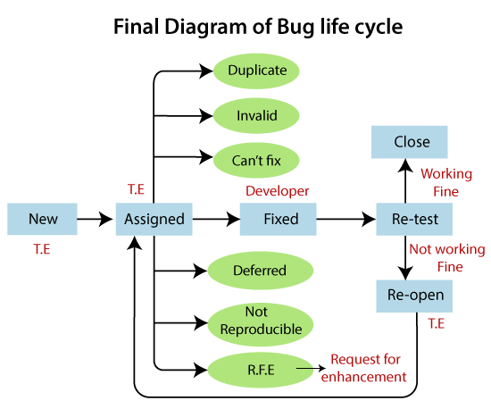

## **What is Severity?**

[**Bug Severity**](https://www.professionalqa.com/defect-severity-in-software-testing) defines the degree of impact of a bug on a software application to produce detrimental results. Greater the severity, larger would be the impact on the functionalities.

## **What is Priority?**

Unlike, bug severity, bug priority defines a bug in the terms of its degree of impact on the business & organizational needs and requirements along with the urgency to fix that bug. Higher the priority, sooner the bug will be resolved.

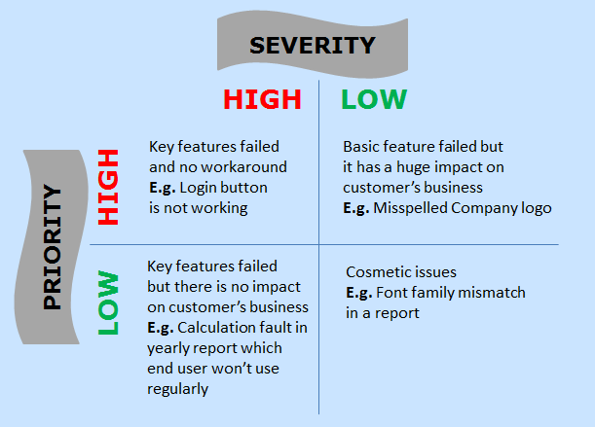

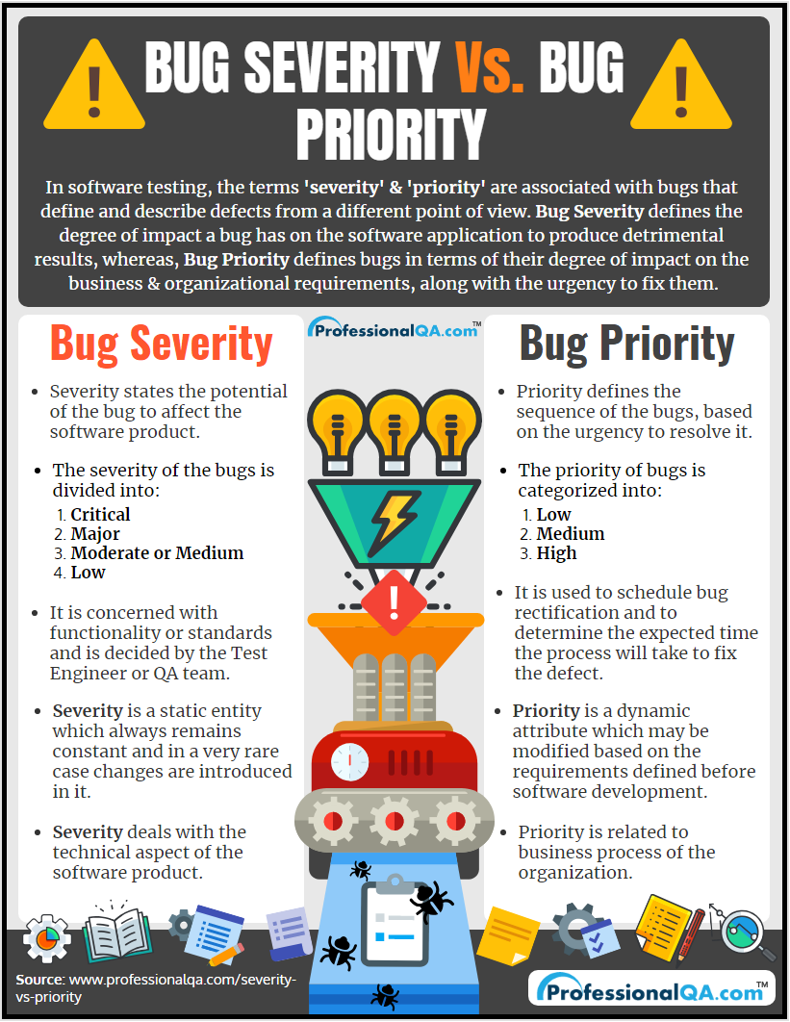

High Priority and High Severity

​In an application, if there is an issue with the login screen and the user is not able to log in, then that defect falls in High Priority, and High Severity as this needs to be resolved first because the user is blocked and cannot access the application further.

High Priority and Low Severity

​If there are some spelling mistakes on the Home page of the application or any other web page which is used frequently is an example of High Priority and Low Severity as Spelling mistakes are not hampering the functionality of the application but making a bad impact on a company’s reputation.

Low Priority and High Severity

​In Online Shopping website, if the ‘Add to Cart’ button stops working if the user tries to add more than 500 items in a cart, then the defect is considered as High Severity as the major functionality is not working as expected but Low Priority because it is a very rare case that user add more than 500 items in cart.

Low Priority and Low Severity

​If there are some spelling mistakes in a paragraph of a page that the user rarely opens, it is considered Low Priority and Low Severity because neither it is creating an impact in the functionality of the application nor any loss to a company’s reputation it is rarely opened.

Test Environments:

